Documentation for I.AM.Robot’s 2020 Robot: Sabre

Find Joystick mappings and the CAN layout in the [Readme](https://github.com/IAMRobot4810/2020InfiniteRecharge4810/blob/master/README.md)

Last updated 23 April 2020 by Caleb Smith

Contents

About the Bot Mechanically 2

High-level Outline of Code 5

Commands 6

Command Done? 7

Drive Subsystem 7

Climb Subsystem 8

Intake Subsystem 8

Index Subsystem 9

Shooter Subsystem 9

Vanna Subsystem 10

Vision Processing 11

# About the Bot Mechanically

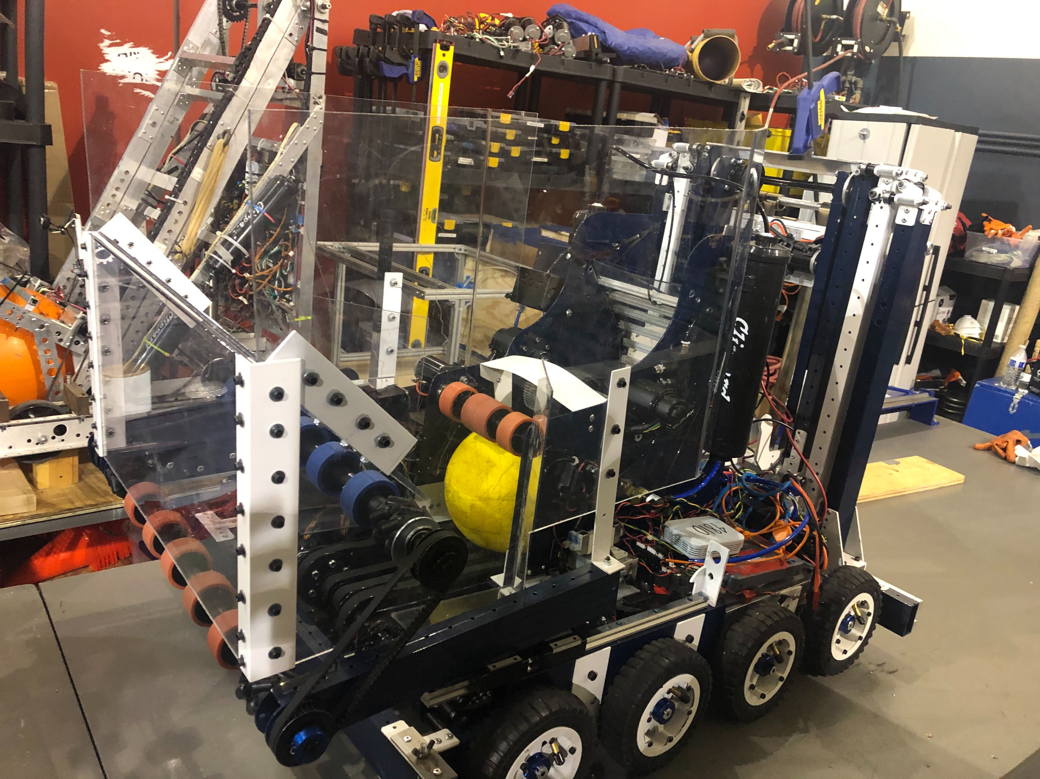

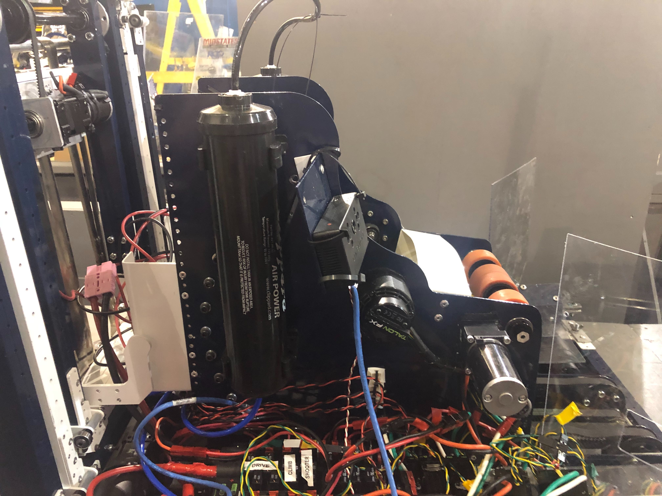

* Drivetrain
  + 2 x Falcon 500 brushless motors per side of differential drivetrain. 8 pneumatic wheels.
* Climb
  + 2 x Falcon 500 motors pull down on an elevator that is spring loaded to go up, with an additional motor flipping up some hooks so it can reach tall enough. Once a mechanical version exists, it will likely have a pneumatic releasing the elevator to spring up. This pneumatic is NOT CODED. Do that.
  + ‘Skywalker’ is an (unlikely) V2 mechanism that will translate horizontally along the Generator Rung.
* Intake
  + Balls enter the bot via a roller that spans the full length of the front bumper which pulls balls up into the hopper. 1 x Bag motor runs the roller, and the whole assembly is actuated in and out of frame perimeter by a pair of pneumatics.
* Index (hopper)
  + A Conveyor ran by a Bag motor spans the length of the hopper across the center of the bottom moving balls backwards. Angled edges funnel balls onto the conveyor.
  + A Feeder Wheel holds balls back from contacting the shooter wheel until its up to speed (a feature partially removed until hopper functionality improves) and which also forces balls into the shooter when its running
* Shooter
  + 2 x Falcon 500 motors run a single-wheeled hooded shooter which shoot the balls out
  + Version 2 of the shooter (which is coming soon) uses a pneumatic to adjust the hood release angle, so that is partially coded.
* Vanna (Control Panel manipulator)
  + Not on the bot
  + Planned to be: 1 x Bag motor drives a wheel which contacts and spins the control panel. Like Vanna White and the wheel of fortune. Actuated out of the way of the control panel by a pneumatic (so we can go under it).
* Vision Processing
  + Uses Limelight 2+ to filter targets and send info on them to robot code via network tables
  + Implemented, but requires PID tuning: driver presses button and robot turns to aim at target using feedback from vision system
  + Later, it may compute the distance to the target and from that, a suitable velocity for the shooter to spin at. Moderate-to-high effort for low value.

# High-level Outline of Code

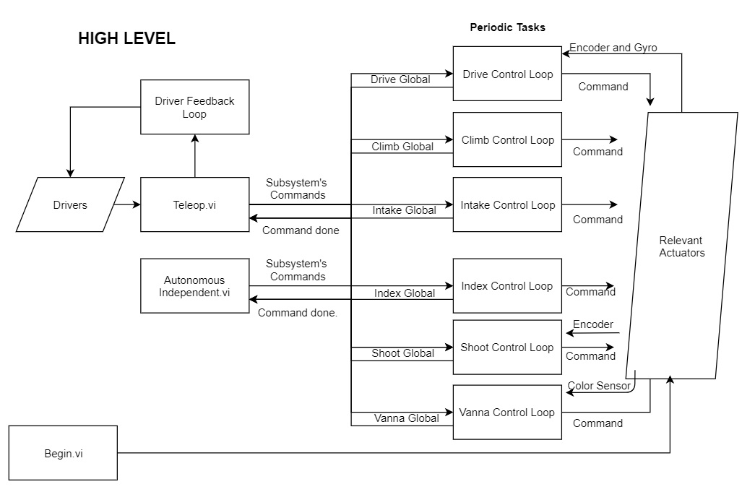

* Begin initializes motors, sensors, pneumatics, etc. This includes defining PID values and Brake/Coast mode, etc.
* Teleop takes driver’s inputs and assigns them to values for the relevant subsystem. It sends these values via ‘commands’ over the subsystem’s global variable
* Autonomous Independent pulls a stored array of commands that will make the robot perform the desired set of actions and feeds them to the subsystem’s globals, one at a time after all subsystems have declared they have finished the prior command. The extra infrastructure in other areas makes this process super elegant.
* Globals convey information between Teleop/Autonomous independent and the subsystem’s control loops. This is mainly Commands and ‘Command Done?’ variables
* Subsystem Control Loops take the Commands from the Subsystem’s Global write it to actuators, and write back whether the subsystem has completed the command based on sensor feedback.

# Commands

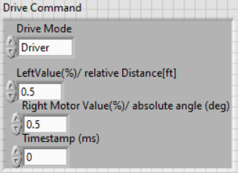 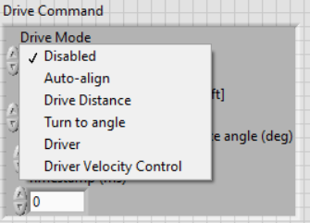

* Commands are a bundle of information that define how a subsystem is to behave.
* The ‘mode’ is an enum which determines how the following parameters will be interpreted; it is the selector for a case structure inside the subsystem control loop
* The parameters (other inputs) are instructions for how to execute the mode. In the example Drive Command screenshot, the driver has told the robot to drive forward at half throttle through the joysticks; therefore, the left and right motor will both be told to drive at half throttle.
* Timestamp serves as a unique ID for a command so that Autonomous Independent knows that it is not reading an outdated ‘Command Done?’ value and can move on to the next step of the autonomous sequence
* As a precaution, some subsystems has a separate variable for Teleop and Auton which is sorted out in the respective control loop based on the field mode. This isn’t necessary, but may prevent weirdness maybe

# Command Done?

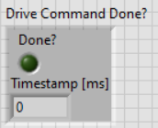

* A cluster of a Boolean and a timestamp.
* The timestamp serves as a unique ID to ensure that Autonomous Independent is does not read an outdated true ‘Done?’ and move on to the next step before the control loop has processed the step and updated the ‘Done?’ value to false. The Timestamps of the Command and ‘Command Done?’ are compared in Autonomous independent before moving on to the next step.

# Drive Subsystem

See precisely how and which joysticks affect the bot’s behavior in the Readme

* Disabled: stops motors
* Auto-align: once completed, will run a RoboRIO-side PID loop (for now, because it seemed easier) from a vision system onto the driver’s turning. Will signal ‘Done’ when error is below pre-set value.
* Drive Distance: For each new command, it finds a destination encoder position based on the current position and the desired increase in position, then sets the motors to motion magic to get to the destination position. Will signal ‘Done’ when error is below pre-set value.
* Turn to angle: Runs the same PID loop as Auto-align based on the Gyro and an absolute angle input from the command. Will signal ‘Done’ when error is below pre-set value.
* Driver: passes % inputs from driver’s joysticks into the left and right motors
* Driver Velocity Control: runs a velocity PID loop on the Falcons based off the driver’s % input converted to a velocity. Supposedly makes the drive base more controllable. Not fully implemented yet.
  + NOTE: since velocity control and position control will inevitably use different PID constants, these can be stored on different “slotldx” on a Falcon/Talon. Use the “select slot” CTRE VI to switch between them. (assign a set of constants to slot 0 for distance and another set to slot 1 for velocity, then switch slots whenever switching modes.) THIS IS NOT IN THE CODE RIGHT NOW BUT IT MUST BE FOR POSITION AND VELOCITY TO COEXIST on a Falcon/Talon.

The control loop front panel graphs position, velocity, and current draw.

# Climb Subsystem

To prevent breaking the climber, a forward soft limit (based on an encoder position) is enabled. The physical climber isn’t done, so the soft limit is untested.

* Disabled: stops all motors
* Raw throttle: passes the % output from the operator directly into the motors
* Maybe in the unlikely far future will add an auto-level mode for Skywalker.

# Intake Subsystem

* Disabled: stops the motor and retracts the pneumatic
* Enabled: passes throttle % and pneumatic state from driver into motor/pneumatic

# Index Subsystem

Didn’t find it worth it to make a complete Command cluster, but for the sake of the system, one should be made.

* If shooter is not disabled, writes the % throttle from the operator to the conveyor and feeder wheel.
* Previously would not run unless shooter was “Done” so that it would not feed balls while the shooter wasn’t up to the preset speed, but because the hopper can’t feed balls fast enough anyway, this feature is currently disabled.

# Shooter Subsystem

Attempts to count number of balls shot by monitoring the current draw for spikes, but that needs more testing before it can be relied upon.

Currently a little messy but that can be cleaned up with sub-Vis

Graphs velocity on the Shooter Control loop front panel

* Disabled: cuts power to motors and extends pneumatic
* Raw Throttle: sets the motor to the same % output as the operator’s input throttle %
* Preset Velocity Control: sets the shooter to a velocity based on a pre-determined speed for a pre-determined shooting location. Uses Velocity PID onboard the Falcons, and sets the reverse limit switch to be normally closed so that it won’t spin backwards, allowing for a more aggressive PID with easier tuning by eliminating oscillation. Retracts the pneumatic (shooting the ball higher) automatically when the operator presses the button to shoot from the target zone (up close). Will signal ‘Done’ when error is below pre-set value.
  + A ‘fine-adjust’ input allows the operator to change the velocity the shooter will spin at, with the maximum speed achieved by holding one button and increasing ‘fine-adjust’ all the way being halfway between the selected preset speed and the next-highest preset speed, with the same applying for the minimum speed. This allows for a continuous range of speeds achievable by the operator, while making the joystick more sensitive. This was done to allow for on-the-fly compensation to torn-up balls that we may encounter.
* Vision-based Velocity Control: once implemented, would calculate the required speed for shooting the ball based on input from the vision system. Not a priority.

# Vanna Subsystem

Currently disabled because its not on the bot so why waste CPU? The defaults for the color sensor RGB values worked pretty well with preliminary testing.

* Disabled: Stops the motor and retracts the pneumatic
* Raw Throttle: Direct the % input from the operator and extend the pneumatic
* Rotation Control: Full throttle and extend pneumatic. Count 28 edges of the control panel from the color sensor to go around 3 rotations and a bit. Then signal ‘done’.
* Position Control: Rotate the wheel and extend pneumatic until the color sensor’s color matches the FMS color. Then signal done. If the operator presses the position control button and the FMS isn’t ready yet, make a pseudo-error.

# Vision Processing

* Limelight 2+ is mounted to the side of the shooter
  + Integrated unit with LEDs, camera, and on-board processing unit. Web-based dashboard lets you tune the pipeline and the Limelight runs it, returning information about the target to the RoboRIO via Network Tables
* Target degrees offset from center in X direction: used in Drive’s Auto-Align. Running an as-of-yet un-tuned PID loop
* Some combination of (Target area, Target degrees offset from center in Y direction, Target width, Target height) can be used to find distance to the target, which can be used to find how fast the shooter should spin. Unimplemented.